Is this the future of organ donation? Scientists grow beating mouse heart made from HUMAN stem cells

U.S. scientists have 'grown' a beating mouse heart from human stem cells, leading many to hope that human organs could one day be created.
The heart - which had been removed from the mouse and stripped of its cells - was treated with human stem cells and started to beat again.
The breakthrough could lead to the development of transplant organs for patients thanks to stem cells produced from simple skin biopsies.

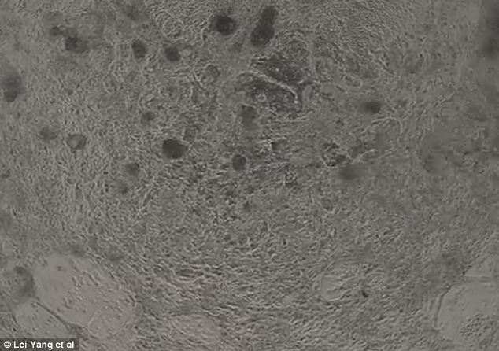
Scientists have 'grown' a beating mouse heart from human stem cells, leading many to hope that human organs could one day be regrown. This image shows a closely packed layer of cells in the cardiac muscles

These specialised cells - induced pluripotent stem cells or iPS cells - are adult stem cells which act like embryonic ones, gaining the ability to become any cell in the human body. But embryos do not have to be destroyed to create a supply.
In principle iPS cells could be used to treat a wide range of disorders, from diabetes to Parkinson's.
Rather than managing the symptoms of the disease, the cells would be used to regenerate the affected parts of the body.

The research, published in Nature Communications said It was the first time that scientists have managed to make a mouse heart beat again after its own cells were stripped and replaced with the human heart precursor cells.
The findings may lead to personalised iPS cells being used in organ transplants one day, while hearts and other organs could also be made to test drugs in the lab.
Heart disease is the UK's biggest killer, causing almost 74,000 deaths each year, about 200 every day.
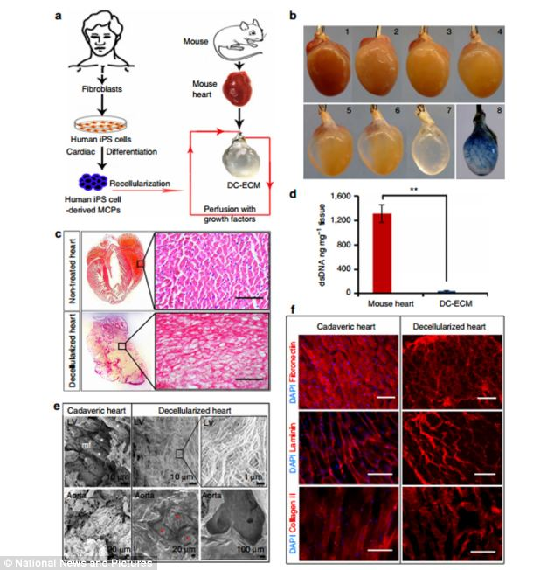
The mouse heart, which was removed from the mouse and stripped of its cells, was treated with human stem cells and started to beat again, as shown in figure a. Figure c and e shows the staining of the mouse heart. Figure d shows powerful microscope images of hearts

In the U.S. one person dies from heart disease every 34 seconds and more than 5 million people suffer from heart failure, meaning a reduced ability to pump blood.
Dr Lei Yang, of the University of Pittsburgh, said more than half of heart disease patients do not respond to current therapies and there is a scarcity of donor organs for transplant.
He said: 'Scientists have been looking to regenerative medicine and tissue engineering approaches to find new solutions for this important problem.
'The ability to replace a piece of tissue damaged by a heart attack, or perhaps an entire organ, could be very helpful for these patients.'
Dr Yang's researchers first removed all the cells from a mouse heart, a process that takes about 10 hours using a variety of agents.
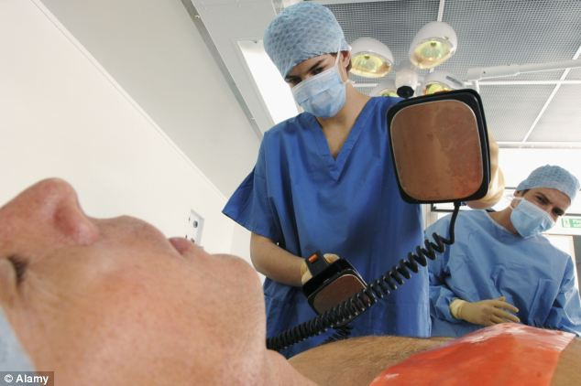
In the U.S. one person dies from heart disease every 34 seconds and more than 5 million people suffer from heart failure, meaning a reduced ability to pump blood. Doctors use a defibrillator to resuscitate a male heart attack victim, pictured

Then they replaced the remaining heart framework with MCP (multipotential cardiovascular progenitor) cells produced by engineering iPS cells from a small human skin biopsy and treating them with special growth factors to further encourage differentiation.
'This process makes MCPs, which are precursor cells that can further differentiate into three kinds of cells the heart uses, including cardiomyocytes, endothelial cells and smooth muscle cells,' said Dr Yang.
'Nobody has tried using these MCPs for heart regeneration before.
'It turns out the heart's extracellular matrix, the material that is the substrate of heart scaffold, can send signals to guide the MCPs into becoming the specialised cells needed for proper heart function.'

A beating engineered heart construct is pictured. Induced pluripotent stem cells, or iPS cells - are adult stem cells which act like embryonic ones, gaining the ability to become any cell in the human body and were used to replace cells from the mouse's heart

After a few weeks, the mouse heart had not only been rebuilt with human cells, it also began contracting again, at the rate of 40 to 50 beats a minute.
The researchers added that more work must be done to make the heart contract strongly enough to be able to pump blood effectively, and to rebuild the heart's electrical conduction system correctly so the heart rate speeds up and slows down appropriately.
Dr Yang said it may be possible in the future to take a simple skin biopsy from a patient to derive personalised MCPs that can be used to seed a biologic scaffold and regenerate a replacement organ suitable for transplantation.
The model also could be used as a lab based method to preclinically test the effect of new drugs on the heart or to study how the foetal heart might develop.
Added Dr Yang: 'One of our next goals is to see if it is feasible to make a patch of human heart muscle. We could use patches to replace a region damaged by a heart attack. That might be easier to achieve because it will not require as many cells as a whole human sized organ would.'
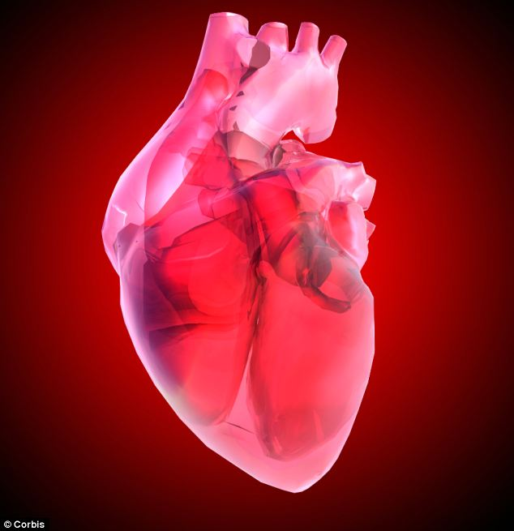
The findings of the study may lead to personalised iPS cells being used in organ transplants one day, while hearts and other organs could also be made to test drugs in the lab. Heart disease is the UK's biggest killer, causing almost 74,000 deaths each year, about 200 every day

